**FOODBORNE DISEASES, INFECTIONS AND INTOXICATIONS**

A Project report submitted in

partial fulfilment of the Requirement for the

degree of B.Sc. Genetics and Biotechnology

Submitted by

**BHUKYA SHIVANI**

HALL TICKET: 11013-21-738

**Under the guidance of**

**Dr. SYEDA AMEENA KAUSAR**

**Assistant professor (C) and I/C Head**

**DEPARTMENT OF GENETICS AND BIOTECHNOLOGY**



**UNIVERSITY COLLEGE FOR WOMEN (AUTONOMOUS) KOTI, HYDERABAD – 500095**

**2021 – 2024**

**CERTIFICATE**

This is to certify that the project entitled **“Food Borne Diseases, Infections and Intoxications”** is a review work carried out by **Bhukya Shivani (Roll NO. 11013-21- 738)** in partial fulfilment of the requirement for the award of degree of Bachelor of Scienceunder my supervision the Department of Genetics and Biotechnology. University for Women, Koti, Hyderabad.

The review work contained in her dissertation has not been submitted in the part or full for the award of Any time diploma or degree of this or any other university.

Signature of supervisor Signature of Head of the Department

**DECLARATION**

I, hereby declare the project entitled **“Food Borne Diseases, Infections and Intoxications”** submitted to the Department of Genetics and Biotechnology, University College for women, Koti, Hyderabad, in partial fulfilment for the award of Degree of Bachelor of science in Genetics and Biotechnology, has been submitted elsewhere in part or full for any other Degree or Diploma.

BHUKYA SHIVANI

11013-21-738

# ACKNOWLEDGMENT

First and foremost, I express my sincere gratitude to my project supervisor

**Dr. Syeda Ameena Kausar**, Assistant Professor Department of Genetics and biotechnology, University college for women, Koti for her guidance during this research and study. Her perpetual energy and enthusiasm has motivated me. In addition , she has always been accessible and willing to help me that paved way for smooth research and proved regarding for me.

My warm and sincere thanks to **Prof M. Vijjulatha**(Vice-chancellor), for initiating the idea of project work as a part of the B.Sc. curriculum and encouraging us to carry out the work

I am thankful to my lectures of the Department of Genetics and Biotechnology **Dr. Rupasree Mukhopadhay, Dr. Rohini Chintha,** and **DR.K.S.N Jyothi** for their valuable suggestions.

I am sincerely thankful to all the other teaching and non -teaching staff of the Department of Genetics and Biotechnology, University college for women, Koti, Hyderabad, for their immense patience and for allowing me to pursue my project work.

Place:- B.Shivani

Date:-

**CONTENTS**

ABSTRACT viii

CHAPTER-1 INTRODUCTION 1

* 1. INTRODUCTION 1
     1. DIFFERENCE BETWEEN FOOD INFECTION AND INTOXICATIONS 2
     2. FOOD POISONING OF BACTERIAL ORIGIN 3

FOOD POISONING OF NON-BACTERIAL ORIGIN 12

AFLATOXICOSIS 13

PREVENTION AND CONTROL MEASURES 14

CHAPTER-2 AIM AND OBECTIVES 14

CHAPTER-3 LITERATURE REVIEW 17

* 1. METHODOLOGY AND SIGNIFICANCE 14
  2. ORGANIZATION OF THESIS 16

CAPTER-4 METHODS AND MATERIALS 19

1. Pathogen Detection and Identification 19
2. Epidemiological Investigations 19
3. Food Sampling and Analysis 20
4. Data Management and Analysis 20
5. Regulatory and Policy Tools 20

21

CHAPTER-5 RESULTS AND DISCUSSIONS 21

* 1. RESULTS 21
  2. DISCUSSIONS 22

CHAPTER-6 CONCLUSION 23

REFERENCE 27

**LIST OF FIGURES**

Fig 1. 1 Food Intoxication 3

Fig 1. 2 food poisoning 4

Fig 1. 3 salmonella food poisoning 4

Fig 1. 4 staphylococcal food poisoning 6

Fig 1. 5 Botulism 8

Fig 1. 6 Clostridium Perfringens 10

Fig 1. 7 Bacillus Cereus 11

**LIST OF TABLES**

|  |  |  |
| --- | --- | --- |
| Table 1 | Staphylococcal Food Poisoning | 9 |
| Table 2 | Aflatoxicosis | 13 |
| Table 3 | cleaning and sanitization | 24 |
| Table 4 | Acronyms | 25 |
| Table 5 | Monitoring and surveillance | 26 |

# ABSTRACT

# Hepatitis A virus. Contamination of food can occur through Foodborne infections and intoxications pose significant public health challenges worldwide, affecting millions of people annually. These illnesses result from the consumption of contaminated food or beverages containing pathogenic bacteria, viruses, parasites, or toxins. Common pathogens responsible for foodborne illnesses include Salmonella, Escherichia coli (E. coli), Campylobacter, Listeria monocytogenes, norovirus, and various sources, including raw animal products, contaminated water, cross-contamination, poor hygiene practices, and unsafe food handling. Symptoms of foodborne illnesses range from gastrointestinal discomfort to more severe outcomes, depending on the type of pathogen and individual susceptibility. Preventing foodborne infections requires implementing improved food safety practices, including proper hygiene, safe food handling, adequate cooking and storage techniques, and sanitation measures. Enhanced surveillance, education, and regulation are essential for reducing the incidence of foodborne illnesses and protecting public health. This abstract provides an overview of the causes, symptoms, prevention, and control measures associated with foodborne infections and intoxications, highlighting the importance of continued efforts to ensure the safety of the food supply.

**CHAPTER-1 INTRODUCTION**

## INTRODUCTION

Foodborne infections and intoxications are significant public health concerns globally, posing risks to millions of individuals each year. These conditions arise from the consumption of food or beverage contaminated with harmful pathogens or toxins, leading to a range of symptoms from mild gastrointestinal discomfort to severe illness and even death. Understanding the causes, transmission routes, and prevention strategies of foodborne illnesses is paramount to safe guarding public health and reducing the burden on healthcare systems .In recent years, the incidence of foodborne infections and intoxications has drawn increased attention due to numerous outbreaks and incidents across different regions. Pathogens such as Salmonella, Escherichia coli (E. coli),Campylobacter, Listeria monocytogenes, norovirus, and hepatitis A virus continue to pose significant threats to food safety, highlighting the need for comprehensive approaches to mitigate risks and ensure the safety of the food supply chain.

This introduction provides an overview of foodborne infections and intoxications, outlining the types of pathogens involved, common sources of contamination, symptoms, and the importance of prevention and control measures. By exploring these key aspects, we can gain insights into the complexity of foodborne illnesses and the critical role of proactive measures in safeguarding public health and promoting food safety. Through collaborative efforts among governments, food producers, healthcare professionals, and consumers, we can work towards minimizing the occurrence of foodborne illnesses.

**AIMS AND OBJECTIVES:**

**AIM:** To study food borne diseases , infections and intoxication

**OBJECTIVE:** Analyse common pathogens in the food research and analyse common pathogens responsible for food borne diseases and types of food poisoning including sources, symptoms, mode of transmission

**CHAPTER-2 LITERATURE REVIEW**

A review of literature on foodborne infections and intoxications would involve examining research articles, scientific publications, and other relevant sources to gather information on various aspects of the topic. Here's a brief overview of what such a review might entail:

* 1. **Epidemiology:** Summarize studies that provide data on the incidence, prevalence, and trends of foodborne infections and intoxications globally and regionally. Highlight any patterns or emerging issues in the epidemiology of these illnesses.
  2. **Pathogens:** Review research on the microbial agents responsible for foodborne infections, including bacteria (e.g., Salmonella, Escherichia coli, Campylobacter), viruses (e.g., norovirus, hepatitis A virus), parasites (e.g., Cryptosporidium, Giardia), and toxins (e.g., Clostridium botulinum, Staphylococcus aureus). Discuss the sources, transmission routes, and characteristics of these pathogens.
  3. **Sources of Contamination:** Examine studies that investigate the sources and pathways of contamination leading to foodborne illnesses. They may include research on raw animal products, cross- contamination, contaminated water, poor hygiene practices, and environmental factors contributing to foodborne outbreaks.
  4. **Symptoms and Effects:** Summarize the clinical manifestations, severity, and outcomes associated with foodborne infections and intoxications. Discuss research on the range of symptoms, complications, and long-term health effects observed in affected individuals.
  5. **Prevention and Control Measures:** Review studies evaluation effectiveness of interventions aimed at preventing and controlling.

foodborne illnesses. This may include research on food safety practices, surveillance systems, regulatory policies, education campaigns, and technological innovations for food safety management.

**2.6 Risk Factors and Vulnerable Populations:** Examine research on factors that increase the risk of foodborne infections and intoxications, such as demographic characteristics, underlying health conditions, dietary habits, and environmental exposures. Discuss studies that identify vulnerable populations, including children, elderly individuals,pregnant women.

* 1. **Economic and Public Health Impact:** Summarize research on the economic burden and public health impact of foodborne infections and intoxications. This may include studies estimating healthcare costs, productivity losses**,** food recalls, and societal implications of food borne out breaks.
  2. **Future Directions:** Discuss gaps in the literature and areas for future research, including the need for multidisciplinary approaches, emerging pathogens, innovative technologies, and policy interventionsto address foodborne illnesses effectively.

By synthesizing findings from existing literature, a review of foodborne infections and intoxications can provide valuable insights into the current state of knowledge, challenges, and opportunities for improving food safety and public health outcomes.

## DIFFERENCE BETWEENFOOD INFECTION AND INTOXICATIONS

+

The microorganisms are:

1. bacteria.
2. fungi.
3. viruses.
4. parasites

These microorganisms enter the body and start grow in gastro intestinal tract, causing a infection.

Symptoms of food infection: symptoms start within a few hours to a few days after consuming contaminated food.

May include:

* Diarrhea
* Fever
* abdominal pain
* Vomiting

**Food intoxications**

Food intoxication is caused by eating food that contains harmful toxinsproduced by certain types of bacteria ,such as

1. cloatridium botulinum
2. staphylococcus aurens
3. bacillus cereus.

These toxins enter the body and cause symptom within a few hours of consuming contaminated food.

Symptoms of food intoxication:

* nausea
* vomiting
* abdominal pain

In severe cases, food intoxications can lead to hospitalization or even death.

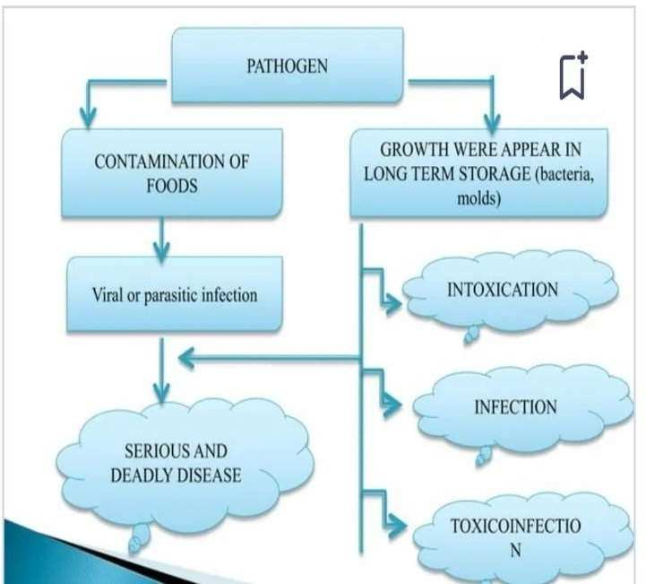

Fig 1. 1 Toxin production during Staphylococcal food poisoning

Image source: Arun K. Bhunia 2018.

## FOOD POISONING OF BACTERIAL ORIGIN

Food poisoning i.e. food infections and intoxications is therefore of two types

1. bacterial origin
2. nonbacterial origin

As we all know that food poisoning occurs due to contamination of food (microorganisms present in food) by bacteria or toxins released by them. Let us discuss about the different bacteria which cause food poisoning and how does organisms enter the food.

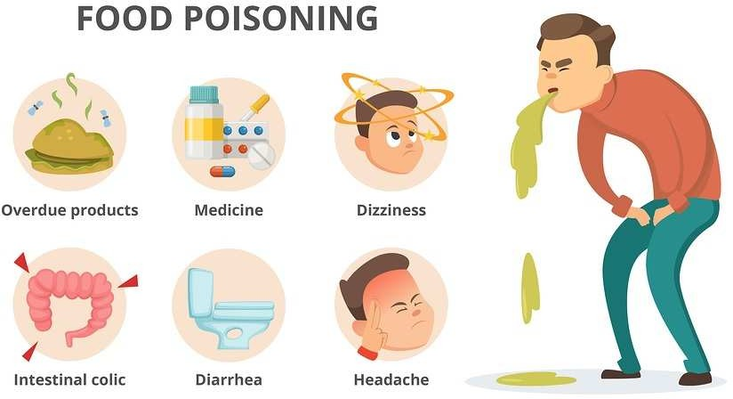

**Salmonella food poisoning**

*Fig 1. 2 food poisoning*

Salmonella food poisoning is a very common form of food poisoning. Its increase in incidence in recent years is attributed to increase in communal feeding activities like in marriages and large parties, increased popularity of ready-to-eat foods, especially tinned foods and certain household practices.

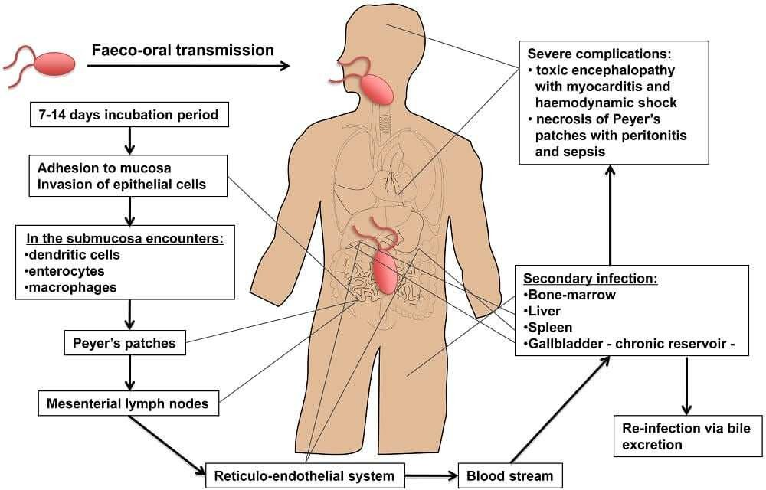

*Fig 1. 3 salmonella food poisoning*

**Causative organism**

The common organisms (bacteria) belonging to salmonella species involved in food poisoning are Salmonella typhimurium, Salmonella Cholera-suis and Salmonella- enteritidis.

**Source of infection**

Food gets infected through contaminated meat, milk and milk products,poultry, egg and egg products. Food also can get infected by rats and mice when the food gets contaminated by their urine and feces.

**Poisoning occurrence**

Contamination of food may occur at the source or by cross- contamination (due to excess of organisms from surroundings or their foods) during processing of food. It can also occur due to contaminationby a carrier or fecal contamination by food handler. The Contaminant organisms on ingestion multiply in the intestine and give rise to sudden onset of diarrhea or vomiting or both.

**Signs and symptoms of salmonellosis**

The onset of the episode is usually sudden, accompanied by chills, fever, nausea, vomiting and a profuse watery diarrhea lasting for 2 to 3 days.Death is reported to occur in about one per cent of cases.

**Susceptible**

Generally, all are susceptible. Debilitating conditions increase the susceptibility

**Incubation period**

The incubation period varies from 12 – 24 hours.

**Period of communicability**

The period of communicability extends throughout the course of the disease

## STAPHYLOCOCCAL FOOD POISONING

Staphylococcus is another common form of food poisoning due tobacterial origin. Staphylococcus toxin is the poison developed by the bacteria when it grows in food. These are the common organism causing boils and common skin infections. Udder infection by Staphylococci in milch cattle leads to contamination of milk and milk products causing

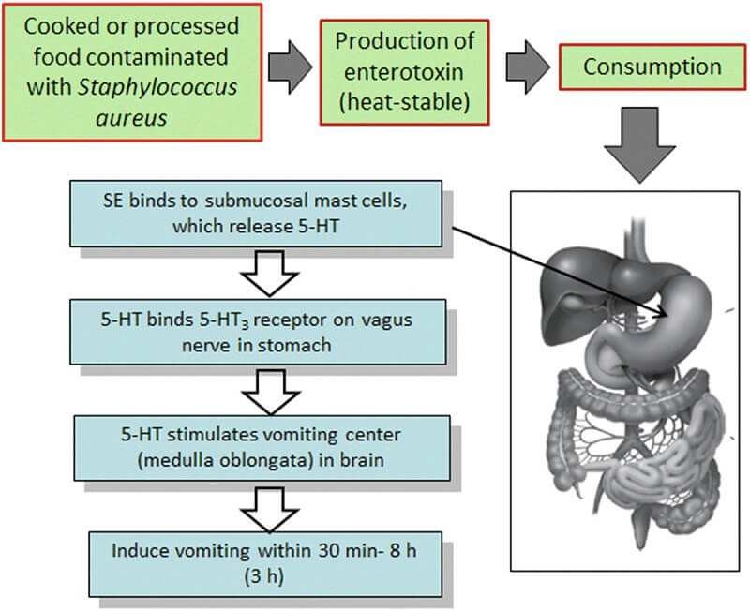episodes of food poisoning. Cooked ham, or other meat, chopped or ground food, warmed-over food are the other source of infection.

*Fig 1. 4 staphylococcal food poisoning*

**Reservoir of infection**

You will find that the most common source of the organism is a food handler who might be suffering from a nose, throat or skin infection (boils, pimples etc.). Another source is milk of a cow with udder infection. If you store food preparations which are thus infected for several hours at room temperature, the bacteria (disease causing organisms) multiply and produce toxins which cause the poisoning.

**Mode of transmission**

Consumption of contaminated food products like pastries, custard, salads, sandwiches, sliced meats and meat products. Contamination occurs from the purulent

discharges from infected fingers, infected eyes,abscesses, nasal secretions and apparently normal skin of food handlers coming in contact with food items, where the bacteria multiply when allowed to stand for several hours before serving. These bacteria liberate and cause outbreaks of food poisoning.

**Poisoning occur**

Food poisoning occurs because of the toxins liberated by the organismsgrowing in the contaminated food. As you have already learnt that the toxin is heat resistant, it can remain in the food and cause harm even after the actual organisms have died. The effect of poisoning is due to the action of toxin on the gut and nervous system.

**Signs and symptoms**

The illness in staphylococcus poisoning is sudden and usually manifestsby onset of vomiting, abdominal cramps and loose motions. When the disease is severe, blood and mucus may appear in the stools. One does not get fever and can recover in one to three days.

**Incubation period**

The incubation period in staphylococcal food poisoning is short and is between 1-6 hours only

**Botulism**

Botulism is a very serious form of food poisoning but fortunately its occurrence is rare. If it occurs, it can kill upto the extent of two thirds of its victims. What is the causative organism? The organism responsible is Clostridium botulinum and it is the toxin liberated by the organism that causes the food poisoning.

What is the source of contamination? The organism that causes poisoning is widely distributed in soil and dust. Toxin produced by Clostridiurn botulinum is the toxic agent. Toxins are produced in improperly processed foods and unrefrigerated foods of low acidity. It is also observed to be present in the intestinal tracts of domestic animals. The organism enters the food as spores. The foods that are commonly affected by botulism poisoning are home preserved foods (pickles, vegetables), home made cheese etc. What is the incubation period? Incubation period for botulism is reported to be from 12 to 36 hours. How does the poisoning occur? Once spores of the organisms enter the food, under favorable anaerobic conditions they grow and liberate the toxin. The toxin thus liberated acts on the nervous system. The effects of the toxin on the gastrointestinal system are minimal.

What is the mode of transmission? Consumption of contaminated food usually consisting of inadequately processed canned items used as it is, without adequate cooking, is responsible for the transmission of the disease. Incidence of botulism as a result of contamination from the infected wounds also is known. What are the signs and symptoms? The prominent symptoms in botulism include: difficulty in swallowing, blurring of vision, double vision, closing of the eyelids, painful joints, weakness of the muscles and sometimes even the paralysis of both hands and legs. Subject is conscious and usually there is no fever. The condition is usually fatal and death results in 4 to 8 days due to failure of functioning of respiration or heart or both.

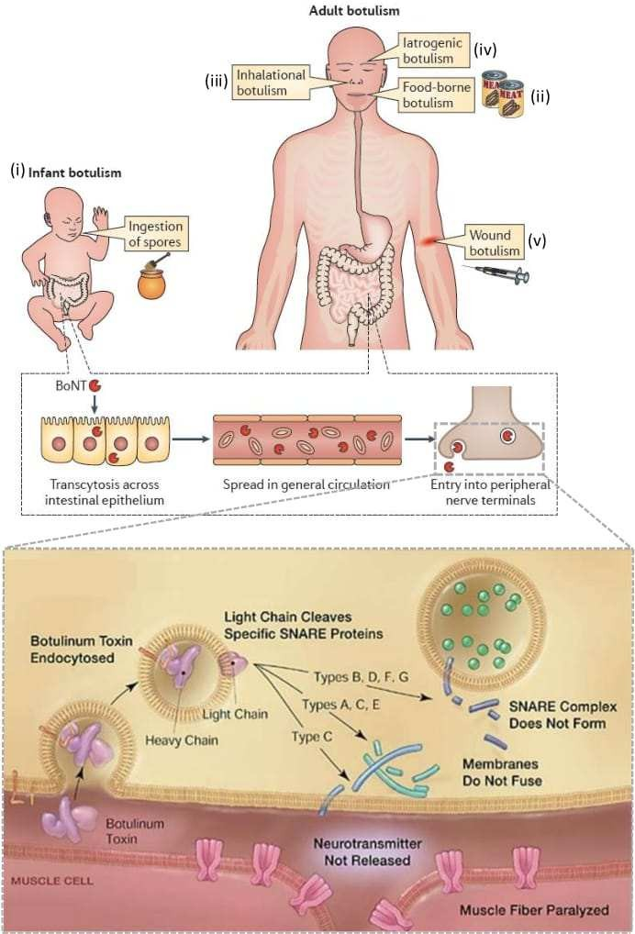

*Fig 1. 5 Types of Botulism ,the structure & mode of action of different botulinum Toxins*

*Reference:* *Courtesy of Arnon SS, et al. Botulinum toxin as a biological weapon: medical and public health management. JAMA 2001 Apr 25;285:1059.*

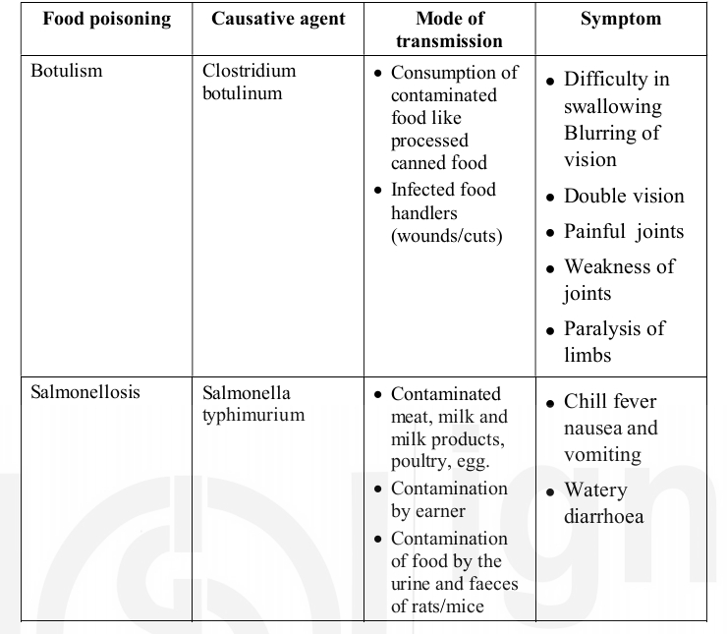Table 1 Staphylococcal Food Poisoning

**Clostridium Perfringens Food Poisoning**

Food poisoning due to Clostridium perfringens is a mild disease of short duration and rarely it is fatal. In very serious conditions deaths are known to occur. What is the causative organism? Some strains of Clostridium perfringens (also known as Evelenii) are the causative agents. Usually, the spores contaminate the food. Toxin produced from this organism causes poisoning. What is the source of infection? As in the case of botulism, in this case also, soil and gastrointestinal tracts of man and animals form the reservoir of infection. Meat which has been boiled, steamed or partially roasted, allowed to cool several hours and subsequently either reheated is another source of infection. How does the poisoning occur? It is the spores which cause the poisoning. It is a natural

contaminant of meat. The spores are able to survive the cooking. The favorable temperature for the organism to multiply is between 30°C to 50°C. What are the signs and symptoms? Sudden onset of colicky abdominal pain followed by diarrhea 8 to 24 hours after consuming contaminated food are the common symptoms. There will be little or no fever. Nausea and vomiting are rare. Illness last usually for a short duration of a day and recovery is rapid. Generally, all are susceptible. What is the incubation period? Incubation period is between 6 to 24 hours with a peak from 10 to 14 hours.

**Bacillus Cereus Food Poisoning**

Bacillus cereus food poisoning is a gastrointestinal disorder occurring due to the contamination of food by a bacillus known as Bacillus cereus. What is the causative organism? The causative organism is Bacillus cereus. It is an aerobic spore bearing, motile rod like bacillus. The organism (spores) can survive cooking procedures. It produces an enterotoxin which is responsible for causing the food poisoning. The toxin liberated is quite stable. What is the source of infection? Bacillus cereus is the source of infection which is found plentiful in the soil and in raw, dried and processed food. How does the poisoning occur? Consumption of contaminated food in conditions favorable for

the multiplication of the bacillus leads to the episode of poisoning. What are the signs and symptoms? Two types of manifestations are known to occur during poisoning by bacillus. In one type sudden onset of nausea and vomiting may occur. In the second type, abdominal colic followed by diarrhea occurs. Fever usually is not associated with the disease. These symptoms generally persist only for a short duration, rarely exceeding 24 hours. Death is rare. Period of communicability and the nature of susceptibility are not yet known. What is the incubation period? Incubation period extends from 1-24 hours and usually around 6 hours. How to differentiate food poisoning from other gastrointestinal diseases? Food poisoning must be differentiated from morbidities like cholera, diarrhea and dysentery or chemical poisoning of the food. The characteristics of the episode are involvement of a group of people at the same time with a history of sharing a common meal and a sudden onset. These suggest the possibility of food poisoning. In addition, if any laboratory investigations are undertaken they will indicate the organism or the agent involved, which will confirm the occurrence of poisoning.

## FOOD POISONING OF NON-BACTERIAL ORIGIN

You may recall reading earlier those moulds, fungus can also cause food poisoning. In addition there might be certain toxins present naturally in foods which may also cause food poisoning. It this section, you will be learning about four important conditions which occur due to toxic contamination of food items. These are of the non-bacterial origin. Among the four conditions described here, Ergotism and Aflatoxicosis are due to fungal and mould contamination of food grains respectively. Lathyrism, the third condition is due to toxic principles present in the food item while Epidemic dropsy is due to contamination of edible oils with argemone oil.

**Ergotism**

Ergotism, is a condition arising due to a field fungus affecting food grains like bajra, rye, sorghum and wheat. The growth of the ergot fungusoccurs during the flowering stage. Consumption of such ergot infested foodgrains leads to the toxic condition known as ergotism. Sporadic outbreaks of ergot poisoning in human beings have been observed fromtime to time where bajra and rye are consumed as staple food.

**Fungus causing ergotism**

The fungus that causes ergotism is identified as Claviceps fusiformis. The fungus grows as a blackish mass and the seeds become black and irregular which are harvested along with the food grains. The ergot produces toxins which result in ergotism.

**Signs and symptoms**

The symptoms of ergotism are acute but rarely they are fatal. The symptoms include nausea, repeated vomiting, giddiness and drowsiness lasting over extended periods of upto two years after ingestion of ergot affected grain. When the condition becomes chronic the patient will complain of painful cramps in limbs, depression, weakness and convulsions. Sometimes blood supply to limbs is affected due to the toxic effect on capillary blood vessels which may result in gangrene. Gangrene is a condition, where body parts begin to get destroyed due to infection. Such parts often have to be cut off otherwise it will spread to other partsof the body.

**Control/prevent ergotism**

The safe limit of ergot alkaloids (toxin) in food material is found to be

0.05 mg/l00 g of the food material You may undertake the health education of the communities by making them aware of the ergotism and its toxic effects.You may also teach them the methods of removal of ergot seeds from the foodgrains. Ergot infested grains can be easily removed by floating them in 20 per cent salt water. This can also be done by hand picking or air floatation

## AFLATOXICOSIS

Aflatoxicosis is a condition brought about by Aflatoxins (a toxin) which are a group of mycotoxins produced by moulds known as Aspergillus flavus and aspergillus parasitious. These moulds usually contaminate the groundnut seedlings. Aflatoxins are toxic to liver. Aflatoxicosis has been implicated as a cause of human hepatic carcinoma (cancer of the liver). Its role in cirrhosis in humans is still under investigation. These toxins can cause outbreaks of fatal diseases characterised by acute enteritis and

hepatitis. In addition to groundnut seedlings, it is now known that the mould can affect other foodgrains like maize, sorghum and many other human foods like parboiled rice, tapioca, wheat etc. Some samples of milk from dairy farms were found to contain aflatoxins. The mould, Aspergillus flavus grows and contaminates the foodgrains under favorable conditions like harvesting, storing and processing in high humidity. Moisture above 16 per cent and temperature between 11° and37°C favour toxin formation.

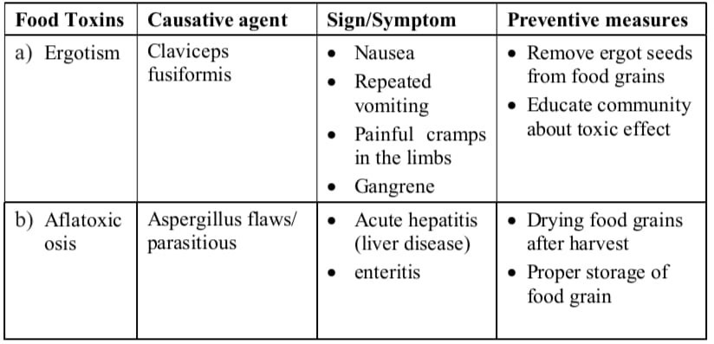Table 2 Aflatoxicosis

**Control/prevent measures**

You have learnt that the important factors leading to contamination are moisture and improper storage. The crucial measure in the prevention ofaflatoxicosis will be thorough drying of foodgrains after harvest followed by proper storage. If any food item is suspected to be contaminated, it must not be allowed for consumption. You should undertake health education of the community on the health hazards of mould contamination of foodgrains.

Control/preventive measures listedin Highlight 6, of unit16, Block 4 of C.

## PREVENTION AND CONTROL MEASURES

Personal hygiene: handwashing. proper food handling practices, etc. Food safety regulations and standards.

Importance of sanitation in food production and processing facilities. Proper cooking and storage techniques.

Surveillance and monitoring systems

# METHODOLOGY

Food poisoning refers to illness caused by consuming contaminated food or beverages. Here's a general methodology to prevent food poisoning

1. **Cleanliness:** Wash hands, utensils, and surfaces frequently, especially after handling raw meat, poultry, seafood, or eggs.
2. **Separation:** Keep raw meats separate from other foods in the refrigerator to prevent cross-contamination.
3. **Cooking:** Cook food thoroughly, especially meat, poultry, eggs, and seafood, to kill harmful bacteria. Use a food thermometer to ensure proper temperatures.
4. **Chilling:** Refrigerate perishable foods promptly, ideally within twohours of purchase or preparation.
5. **Awareness:** Be mindful of expiration dates and signs of spoilage. When in doubt, throw it out.
6. **Hydration:** Drink clean, safe water and avoid consumingunpasteurized dairy products or juices.
7. **Education:** Stay informed about food safety guidelines and practices, especially when handling or preparing food at home.

Following these steps can significantly reduce the risk of foodborne illness. If you suspect food poisoning, seek medical attention promptly.

# SIGNIFICANCE

Food poisoning is significant for several reasons:

1. **Health Impact:** It can cause a range of symptoms from mild discomfort to severe illness, including nausea, vomiting, diarrhea, abdominal pain, fever, and dehydration. In vulnerable populations such as children, elderly individuals, pregnant women, and those with weakened immune systems, food poisoning can be particularlydangerous and even life-threatening.
2. **Economic Impact:** Food poisoning outbreaks can have significant economic consequences, both for individuals who may incur medical expenses and miss work, and for businesses, which may face legal costs, loss of reputation, and financial losses due to recalls and decreased sales.
3. **Public Health Concern:** Foodborne illnesses can spread rapidly through contaminated food, affecting large numbers of people across different geographic areas.

Identifying and preventing outbreaks is a

priority for public health agencies to protect the well-being of communities.

1. **Food Safety Regulations:** Incidents of food poisoning often lead to stricter regulations and enforcement measures to improve food safety standards and prevent future outbreaks. This includes measures such as enhanced food handling procedures, inspections, and monitoring systems throughout the food production and distribution chain.
2. **Consumer Awareness:** Food poisoning incidents raise awareness among consumers about the importance of safe food handling practices, proper storage, and cooking techniques to minimize the risk of contamination and illness. This can empower individuals to make informed choices about the food they consume and advocate for safer food practices within their community

**CHAPTER-3**

**METHODS AND MATERIALS**

The methods and materials used in studying foodborne infections and intoxications

typically involve a combination of laboratory techniques, epidemiological investigations, and data analysis. Here's an overview of the key methods and materials commonly employed:

### Pathogen Detection and Identification:

* + Laboratory culture methods: Isolation and cultivation of food borne pathogens from food samples or clinical specimens using selective media and culture techniques.
  + Molecular methods: Polymerase chain reaction (PCR), sequencing, and other molecular techniques for detecting and identifying specific pathogens based on their DNA or RNA.
  + Immunological assays: Enzyme-linked immunosorbent assays (ELISA), immunofluorescence assays (IFA), and other immunological methods for detecting pathogens or their toxins in food or clinical samples.

### Epidemiological Investigations:

* + Case-control studies: Comparing individuals with foodborne illness (cases) to those without illness (controls) to identify potential risk factors and sources of contamination.
  + Outbreak investigations: Tracing the source of foodborne outbreaks through epidemiological analysis, including interviewing affected individuals, conducting food histories, and analyzing food samples.
  + Surveillance systems: Monitoring and reporting cases of foodborne illness through national or regional surveillance systems to detect outbreaks and track trends over time.

.

# 

### Food Sampling and Analysis:

* + Random sampling: Collecting representative samples of food products from various sources, including farms, processing facilities, retail outlets, and consumer households.
  + Microbiological analysis: Testing food samples for the presence of pathogens, indicator organisms, or spoilage microorganisms using standard microbiological methods.
  + Chemical analysis: Screening food samples for chemical contaminants, toxins, or adulterants using chromatography, spectroscopy,or immunoassays.

### Data Management and Analysis:

* + Database systems: Storing, organizing, and managing data collectedfrom laboratory analyses, epidemiological investigations, and surveillance systems.
  + Statistical analysis: Analyzing epidemiological data, laboratory results, and other relevant information using statistical software to identify associations, trends, and patterns related to foodborne infections.
  + Geographic information systems (GIS): Mapping and visualizing spatial data, including the distribution of foodborne illnesses, outbreak locations, and environmental factors.

### Regulatory and Policy Tools:

* + Food safety regulations: Implementing and enforcing regulatorystandards for food production, processing, distribution, and labeling to prevent foodborne infections and intoxications.
  + Risk assessment: Evaluating the potential hazards associated with specific food products or production processes and determining appropriate control measures to mitigate risks.

These methods and materials play a crucial role in identifying, monitoring, and controlling foodborne infections and intoxications, ultimately contributing to the protection of public health and safety.

**CHAPTER-4 RESULTS AND DISCUSSIONS**

## RESULTS

1. **Incidence and Prevalence:** Present data on the incidence and prevalence of foodborne infections and intoxications, including trends over time and variations by geographic region, age group, and demographics characteristics.
2. 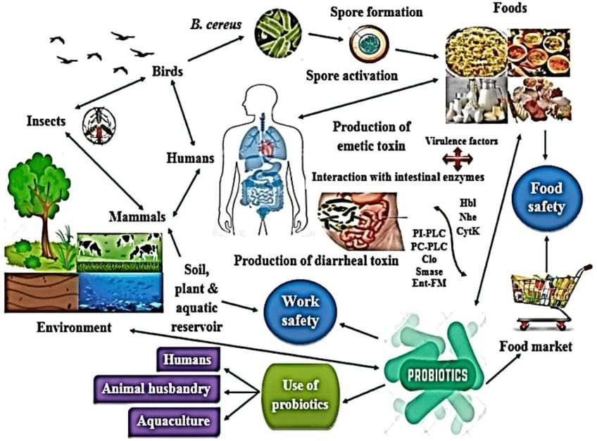**Pathogen Distribution:** Summarize the distribution of different pathogens responsible for foodborne illnesses, highlighting the mostcommon organisms implicated in outbreaks and sporadic cases.

*Fig 1. 7 Bacillus Cereus*

Reference: Bacillus cereus transmission from environment to human food chain (Bamnia and Kaul 2015; Chen et al. 2018; Cui et al. 2019; Ehling-Schulz et al. 2019; Fu et al. 2020).

*Fig 1. 6 Clostridium Perfringens*

*Fig 1. 6 Clostridium Perfringens*

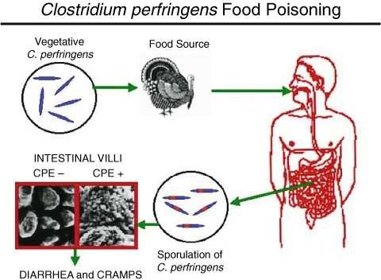

*Fig 1. 6 Clostridium Perfringens*

Reference:[https://link.springer.com/referenceworkentry/10.1007/0-387-307443_22#auth-Francisco_A_-Uzal](https://link.springer.com/referenceworkentry/10.1007/0-387-307443_22%23auth-Francisco_A_-Uzal)

1. **Source Attribution:** Discuss the sources of contamination associated with foodborne infections, including raw animal products, contaminated water, cross-contamination, and environmental factors.
2. **Outbreak Investigations:** Present findings from outbreak investigations, including the identification of outbreak sources, transmission routes, and contributing factors.
3. **Surveillance Data:** Provide information on the surveillance of foodborne illnesses, including reporting systems, case detection methods, and the identification of emerging pathogens or trends.

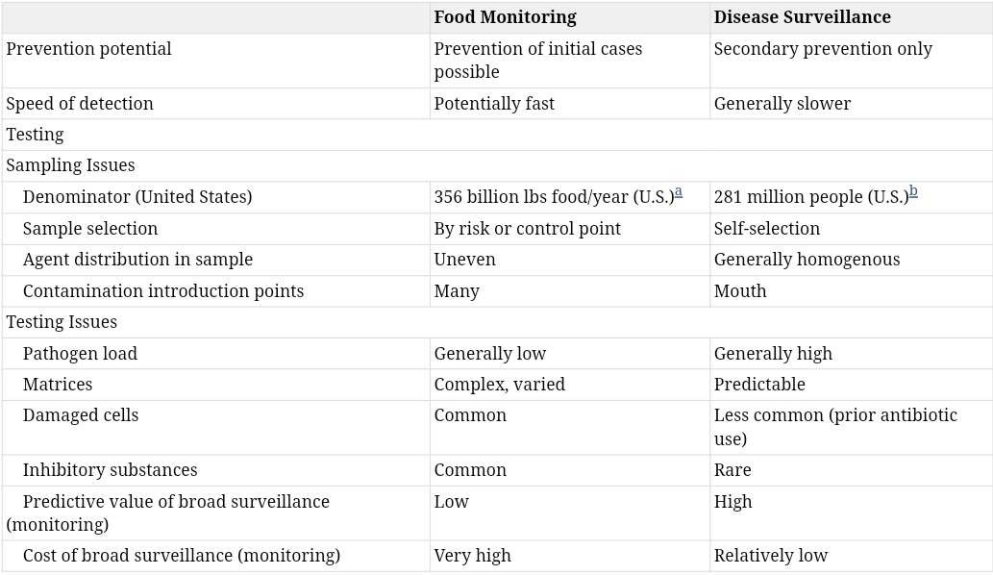

*Table 5 Monitoring and surveillance*

1. **Risk Factors:** Identify risk factors associated with foodborne infections and intoxications, such as dietary habits, food handling practices, demographic characteristics, and environmental exposures.

## DISCUSSIONS:

1. **Public Health Implications:** Interpret the results in the context of their public health significance, discussing the burden of foodborne illnesses on healthcare systems, economic costs, and societal impacts.
2. **Prevention Strategies:** Evaluate the effectiveness of existing prevention strategies and interventions, including food safety regulations, education campaigns, and control measures implementedthroughout the food production and supply chain.
3. **Challenges and Limitations:** Discuss challenges and limitations encountered in studying and controlling foodborne infections, such as underreporting of cases, surveillance gaps, and difficulties in source attribution.
4. **Future Directions:** Propose areas for future research and action, including the development of new detection methods, improvements in surveillance systems, and the implementation of innovative approachesto reduce the incidence of foodborne illnesses.
5. **One Health Approach:** Emphasize the importance of a One Health approach to addressing foodborne infections, recognizing the interconnectedness of human, animal, and environmental health in preventing and controlling disease transmission.
6. **Collaboration and Partnerships:** Highlight the need for collaboration among stakeholders, including government agencies, healthcare providers, food producers, academia, and consumers, to effectively address the complex challenges posed by foodborne infections and intoxications. By presenting and discussing the results ofstudies on foodborne infections and intoxications, researchers and policymakers can inform evidence-based decision-making, improve public health outcomes, and advance efforts to ensure the safety and integrity of the food supply.

**CHAPTER-5 CONCLUSION**

Food safety measures are essential practices implemented to prevent foodborne illnesses

and ensure the safety of the food supply. Here are some key food safety measures:

### Personal Hygiene:

* + Proper handwashing: Thoroughly wash hands with soap and water before handling food, after handling raw meat, poultry, or eggs, after using the restroom, and after touching animals.
  + Clean clothing and protective gear: Wear clean attire, hair nets, and gloves when handling food to prevent contamination.
  + Avoid working while sick: Food handlers with symptoms such as vomiting, diarrhea, or fever should refrain from preparing or serving food.

### Safe Food Handling Practices:

* + Separate raw and cooked foods: Use separate cutting boards, utensils, and surfaces for raw meats, poultry, seafood, and eggs to prevent cross-contamination.
  + Cook food thoroughly: Ensure that foods, especially meat, poultry,seafood, and eggs, are cooked to safe internal temperatures to killharmful bacteria.
  + Proper storage: Store perishable foods in the refrigerator or freezer promptly after purchase and follow storage guidelines to prevent spoilage and bacterial growth.
  + Avoid thawing foods at room temperature: Thaw frozen foods in the refrigerator, under cold running water, or in the microwave to prevent bacterial growth.

### Cleaning and Sanitization:

* + Clean surfaces and utensils: Wash cutting boards, countertops, utensils, and kitchen equipment with hot, soapy water after each use to remove food residues and bacteria.
  + Sanitize surfaces: Use a bleach solution or commercial sanitizer to disinfect surfaces and reduce the risk of contamination.
  + Regular maintenance: Clean and sanitize kitchen equipment, appliances, and food storage areas regularly to prevent the buildup of bacteria and mold.

*Table 3 cleaning and sanitization*

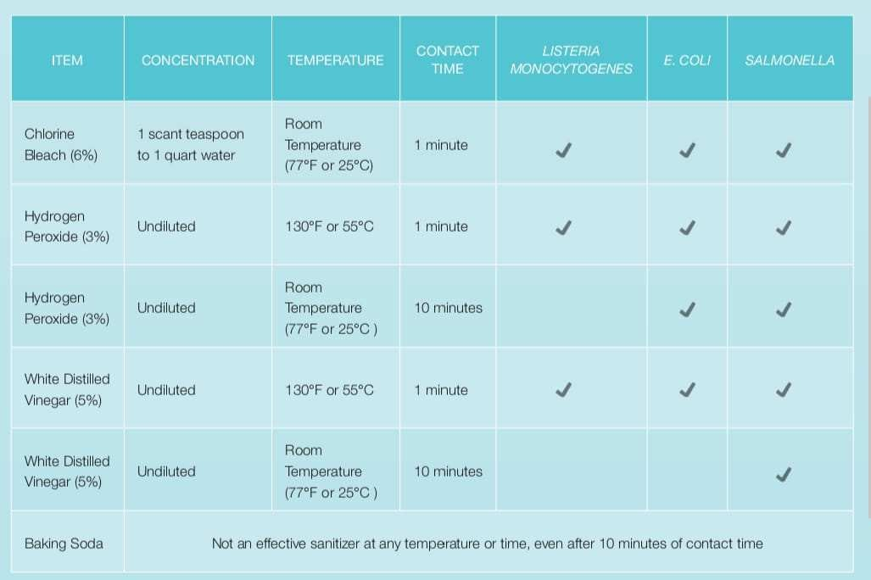

### Food Safety Management Systems:

* + Hazard Analysis and Critical Control Points (HACCP): Implement HACCP principles to identify, evaluate, and control food safety hazardsthroughout the food production process.
  + Good Manufacturing Practices (GMPs): Adhere to GMPs to maintain clean and

sanitary conditions in food processing facilities and minimize the risk of contamination.

### Monitoring and Surveillance:

* + Food safety testing: Conduct regular microbiological testing of food samples to detect the presence of pathogens and ensure compliance withsafety standards.
  + Surveillance systems: Monitor and track foodborne illnesses through surveillance systems to identify outbreaks, trends, and emerging pathogens.

### Education and Training:

* + Food safety education: Provide training and educational materials tofood handlers, producers, and consumers on proper food handling practices, hygiene, and sanitation.
  + Certification programs: Encourage food handlers to undergo food safety certification programs to gain knowledge and skills in safe food handling.

By implementing these food safety measures consistently, individuals, food businesses, and regulatory agencies can minimize the risk of foodborne illnesses and ensure the safety of the food supply for consumers.

# REFERENCE

1. Pepin, J., Abou Chakra, C. N., Pepin, E., Nault, V., & Valiquette, L. (2014). Evolution of the global burden of viral infections from unsafe medical injections, 2000–2010. PloS one, 9(6), e99677. DOI: https://doi.org/10.1371/journal.pone.0099677
2. Lanphear, B. P., Linnemann, C. C., Cannon, C. G., DeRonde, M. M., Pendy, L., & Kerley, L.

M. (1994). Hepatitis C virus infection in healthcare workers: risk of exposure and infection. Infection Control & Hospital Epidemiology, 15(12), 745-750. DOI: https://doi.org/10.2307/30148418

1. Nagham, M. A., Aseel, M. J., Alsbr, IK. A. (2020). Public Health in Hospitals. Eliva Press, 1st Edition. ISBN: 9798636352129.
2. Aseel Mahmood Jawad., Nagham Mahmood Aljamali ., Aseel, M. J. (2020). Innovation, Preparation of Cephalexin Drug Derivatives and Studying of (Toxicity & Resistance of Infection). International Journal of Psychosocial Rehabilitation, 24(04), 3754-3767., DOI: 10.37200/IJPR/V24I4/PR201489 . Available at:’s Research Consortium (GAJRC) 60 https://[www.researchgate.net/profile/NaghamAljamali/publication/339910342_Innovation_Prepar](http://www.researchgate.net/profile/NaghamAljamali/publication/339910342_Innovation_Prepar) ation_of_Cephalexin_Drug_Derivatives_and_Studying_of_Toxicity_Resistance_of_Infection/lin ks/5e6b7c11458515e55576b577/InnovationPreparation-of-Cephalexin-Drug-Derivatives and Studying-of-Toxicity-Resistance-of-Infection.pdf
3. Bell, D. M. (1997). Occupational risk of human immunodeficiency virus infection in healthcare workers: an overview. The American journal of medicine, 102(5), 9-15. DOI: https://doi.org/10.1016/S0002-9343(97)89441-7
4. Rasool, S. R., Aljamali, N. M., & Al-Zuhairi, A. J. (2020). Guanine substituted heterocyclic derivatives as bioactive compounds. Biochem. Cell. Arch, 20(Supplement 2), 3651-3655.
5. Aljamali, N. M. (2015). Synthesis and chemical identification of macro compounds of (Thiazol and Imidazol). Research Journal of Pharmacy and Technology, 8(1), 78-84.
6. Mitsui, T., Iwano, K., Masuko, K., Yamazaki, C., Okamoto, H., Tsuda, F., & Mishiro, S. (1992). Hepatitis C virus infection in medical personnel after needlestick accident. Hepatology, 16(5), 1109-1114.
7. Alsabri, I. K. A., Abdullabass, H. K., & Aljamali, N. M. (2020). Invention of (Gluta. Sulfazane-Cefixime) Compounds as Inhibitors of Cancerous Tumors. Journal of Cardiovascular Disease Research, 11(2), 44-55.
8. Aljamali, N. M., & Al Najim, M. M. (2020). Review in Hospital-Acquired Infection. International Journal of Advances in Engineering Research, 20(3), 7-20.
9. Jain, S. K., Persaud, D., Perl, T. M., Pass, M. A., Murphy, K. M., Pisciotta, J. M., ... & Sullivan, D. J. (2005). Nosocomial malaria and saline flush. Emerging infectious diseases, 11(7), 1097. DOI: https://dx.doi.org/10.3201%2Feid1107.050092
10. Leung, M., & Chan, A. H. (2006). Control and management of hospital indoor air quality. Medical science monitor, 12(3), SR17-SR23. Available at: https://[www.medscimonit.com/abstract/index/id](http://www.medscimonit.com/abstract/index/id) Art/447117/act/3
11. Jawad, A. M., Aljamali, N. M., Jwad, S. M., MJ, A., & MJ, S. (2020). Development and Preparation of ciprofloxacin Drug Derivatives for Treatment of Microbial Contamination in Hospitals and Environment. Indian Journal of Forensic Medicine & Toxicology, 14(2), 1115- 1122.
12. Chan, P. C., Huang, L. M., Lin, H. C., Chang, L. Y., Chen, M. L., Lu, C. Y., ... & Chen, Y.

C. (2007). Control of an outbreak of pandrug-resistant Acinetobacter baumannii colonization and infection in a neonatal intensive care unit. Infection control and hospital epidemiology, 28(4), 423-429. Available at: https://pubmed.ncbi.nlm.nih.gov/17385148/

1. Traub-Dargatz, J. L., Weese, J. S., Rousseau, J. D., Dunowska, M., Morley, P. S., & Dargatz,

D. A. (2006). Pilot study to evaluate 3 hygiene protocols on the reduction of bacterial load on the hands of veterinary staff performing routine equinephysical examinations. The Canadian Veterinary Journal, 47(7), 671. Available at: https://[www.ncbi.nlm.nih.gov/pmc/articles/PMC](http://www.ncbi.nlm.nih.gov/pmc/articles/PMC) 1482439/

1. Aljamali, N. M., Abdullabass, H. K., Jawad, A. M., Alfatlawi, I. O., & Jawd, S. M. (2020). Review on Types of Automatic Sterilization Systems in Hospitals. International Journal of Industrial Biotechnology and Biomaterials, 6(1), 15-21p.
2. Kolář, M., Urbánek, K., & Látal, T. (2001). Antibiotic selective pressure and development of bacterial resistance. International journal of antimicrobial agents, 17(5), 357-363.
3. Haverstick, S., Goodrich, C., Freeman, R., James, S., Kullar, R., & Ahrens, M. (2017). Patients’ hand washing and reducing hospital-acquired infection. Critical care nurse, 37(3), e1- e8.
4. Arrowsmith, V. A., Maunder, J. A., & Taylor, R. (2001). Removal of nail polish and finger rings to prevent surgical infection. Cochrane database of systematic reviews, (1). DOI: https://doi.org/10.1002/14651858.CD003325
5. Namekar, M., Ellis, E. M., O'Connell, M., Elm, J., Gurary, A., Park, S. Y.,& Nerurkar, V. R. (2013). Evaluation of a new commercially available immunoglobulin M capture enzyme-linked immunosorbent assay for diagnosis of dengue virus infection. Journal of clinical microbiology, 51(9), 3102-3106. Available at: https://jcm.asm.org/content/51/9/3102.short
6. Kendall, A., Landers, T., Kirk, J., & Young, E. (2012). Point-of-care hand hygiene: preventing infection behind the curtain. American journal of infection control, 40(4), S3-S10. DOI: https://doi.org/10.1016/j.ajic.2012.02.009
7. Health Quality Ontario. (2018). Portable ultraviolet light surface-disinfecting devices for prevention of hospital-acquired infections: a health technology assessment. Ontario health technology assessment series, 18(1), 1. Available at: https://[www.ncbi.nlm.nih.gov/pmc/articles/PMC](http://www.ncbi.nlm.nih.gov/pmc/articles/PMC) 5824029/
8. Weber, D. J., Kanamori, H., & Rutala, W. A. (2016). ‘No touch’technologies for environmental decontamination: focus on ultraviolet devices and hydrogen peroxide systems. Current opinion in infectious diseases, 29(4), 424-431. DOI: https://doi.org/10.1097/QCO.000000000000028 4
9. Klevens, R. M., Edwards, J. R., Richards Jr, C. L., Horan, T. C., Gaynes, R. P., Pollock, D. A., & Cardo, D. M. (2007). Estimating health care-associated infections and deaths in US hospitals, 2002. Public health reports, 122(2), 160-166. DOI: https://doi.org/10.1177%2F0033354907122002 05
10. Dai, T., Vrahas, M. S., Murray, C. K., & Hamblin, M. R. (2012). Ultraviolet C irradiation: an alternative antimicrobial approach to localized infections?. Expert review of anti-infective therapy, 10(2), 185-195. DOI: https://doi.org/10.1586/eri.11.166